# Nordic CAA Conference 2020, Oslo, 8-9th October 2020

**Call for papers is open until the 5th June 2020.**

CAA-Norway are proud to be hosting a Nordic CAA conference in 2020, in collaboration with CAA-Sweden and CAA-Denmark. The conference will take place in Oslo, on the 8-9th of October.

Abstracts of 2-300 words can be submitted for papers on digital solutions in archaeological research and heritage management. Critical reflections, theoretical approaches, new research, and future challenges on a range of fields are welcomed, including remote sensing, 3D solutions, photogrammetry, GIS solutions, big data, field documentation, collections and digital resource management.

Abstracts and papers can be in any Scandinavian language, or English.

We would like to see a broad range of approaches represented, so feel free to send in abstracts on themes not explicitly mentioned above.

Abstracts can be submitted using the link below, or by following the link of CAA Norges facebook/ webpage:

<https://nettskjema.no/a/142654>

Registration will be opened in the coming weeks.

## The Venue

The conference will be held at the University of Oslo’s conference venue, Professorboligen, located in central Oslo. The venue is a short walk from many good hotels, and has excellent transport links nearby.

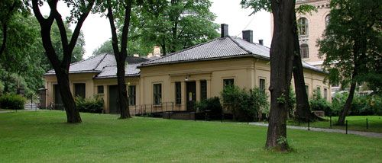

Further information will be posted on the CAA website and facebook pages. Please do not hesitate to contact us with any questions.

Contact information: Rebecca J S Cannell (rebecca.cannell@iakh.uio.no)